

Temasek Polytechnic

School of Informatics and IT
Diploma in Cybersecurity and Digital Forensics (CDF)
AY 2023/2024 Sem

Student Internship Programme Report /
Overseas Student Internship Programme Report

Company Name: NCS PTE LTD
Duration of internship: 5.5 Months
Supervisor: Mr. Daniel Lee, Reporting Officer, NCS Pte Ltd
Submitted To: Mr. Shaun Tan, Liaison Officer, Temasek Polytechnic (School of Informatics and IT)
Submitted By: Isaac Tan, 2100902B

Introduction and Organisational Awareness

1. Introduction
The primary objective of this report is to provide a comprehensive overview of my internship journey and experience at NCS. By delving into specific aspects such as the work environment, organisation structure, nature of business, and diversity and inclusivity, this report seeks to provide a comprehensive understanding of the different experiences and learnings gained during my time at the company.
The work environment, for instance, plays a crucial role in shaping one's professional development, influencing adaptability and productivity. Examining the organizational structure and nature of business offers insights into the company's operations and strategic focus, providing valuable context to my internship experience.
Furthermore, assessing diversity and inclusivity practices sheds light on the company's commitment to fostering an inclusive work environment.
Finally, concluding with a personal reflection allows a holistic evaluation of my overall experience, encompassing both professional growth and personal insights gained from this enriching internship opportunity.

2. Organisation Structure

2.1 History and Summary
Founded in 1981, NCS, previously known as National Computer Systems, is a multinational information technology company based in Singapore. It was founded as a governmental agency, privatised in 1996 and joined Singtel group the following year.
Staffed with more than 12,000 and located in more than 20 cities across Asia Pacific, NCS has grown into a prominent leading technology and information services and partnered with governments and business that offer a range of comprehensive technological solutions and essential services. They also emphasise building strong partnerships with key technology entities, research institutions, and startups for open innovations.

2.2 Hierarchy
The company's hierarchy is defined by distinct levels of authority and responsibility. At the top, the executive leadership team, including the CEO, CTO, and CFO, sets strategic direction and oversees performance. They work closely with the Vice Presidents and Directors, who manage HR and other specific departments. This middle management ensures smooth operations and communication flow between top leadership and frontline employees, who form the backbone of day-to-day tasks.

2.3 Work Culture
In the workplace, our work culture consists of multiple values. My co-workers and I always have trust and respect for each other, enjoying working together, fostering a friendly and comfortable workspace for everyone. Because we are seen as equals, we are able to share our opinions and communicate with each other without the fear of being ostracised and being looked down upon. This allows us to accomplish tasks flawlessly.

3. Work Environment

3.1 Location
On 20th April 2023, I was deployed by NCS to Hillview Camp to assist with the Tech Refresh team. Located opposite Cashew MRT, it takes about 1.5 hours of travelling from my home in Tampines. Commute was a significant factor in my experience, given my residence in the far east and the daily journey to the far west for work. This becomes increasingly challenging during peak hours, when trains were densely packed. Yet, over time, I acclimated to this demanding routine.
Since it is a MINDEF campsite, it is a secure facility with white, green, and red zones that indicate whether camera phones or even certain individuals are permitted in that area. It requires strict clearance to enter the premises, for which I was already cleared by NCS after attending a security briefing. To enter the premises, I have to exchange our NRIC at the Pass Office for a Contractor pass, and then exchange it back at the end of the day when leaving the camp.

3.2 Environment
The workplace uses the camp’s Multi-Purpose Hall (MPH) for day-to-day operations, and it is not the typical office environment with air-conditioning, and everyone formally dressed as one would imagine. Instead, it is an open-space hall with two large ceiling fans. It gets extremely humid most of the time, and I was constantly sweating buckets. It definitely took me very long to get used to working in this environment, but in the end, I became accustomed to it.
We also use canteen-like tables and benches for our workstations, with wires and cables from plug extensions scattered on the floor around the workstations for charging laptops or LAN cables from switches. Hence, it is crucial to always watch our step when walking around to prevent any workplace injuries.
Overall, it definitely took me quite some time to adjust and get used to everything in my new workspace. Experiencing such a drastic difference in work environments compared to what I had ever imagined gave me a culture shock. However, I managed to get a hold of everything as the weeks went by.

4. Nature of Business

4.1 Objectives
The primary objective for the Tech Refresh project team mainly revolves around re-imaging users’ laptops. For example, users such as MINDEF’s military officers come with a number of laptops to request for re-imaging. The re-imaging process involves the following steps: cloning, configuring, followed by joining domain (JD). We allocate roles based on individual strengths and daily manpower, ensuring cohesiveness, as each role plays a pivotal part in the process. There are always many laptops to complete within a given deadline and we always try to hit the Key Performance Index (KPI) given by higher-ups to monitor our work progress, such as 80 completed laptops daily.
Upon getting the user’s laptops, I inspect them for any external damages. Afterwards, I place them into locker cabinets where they will be taken out, sometimes depending on the user’s urgency, to start the re-imaging process. Sometimes instead of working on re-imaging users’ laptops, we would unbox new laptops to clone them for future use, for instances when users come to us with a request of how many new laptops are needed for their camp. From there, we configure and assign accordingly to the requested campsite and JD, to be ready for collection.

4.2 The Process
When checking for any external damages, I look out for instances such as keyboard, mouse, touchpad or touchscreen not working. Then, I start the cloning process by resetting the laptop’s security settings in the BIOS boot menu and then factory resetting the laptop to wipe out all existing data from the previous user to ensure all personal data in the laptop is not accessible to anyone.
Next, I plug in a Solid State Drive (SSD) into the laptop that contains all necessary images and files required for re-imaging, shown in Figure 1 below.
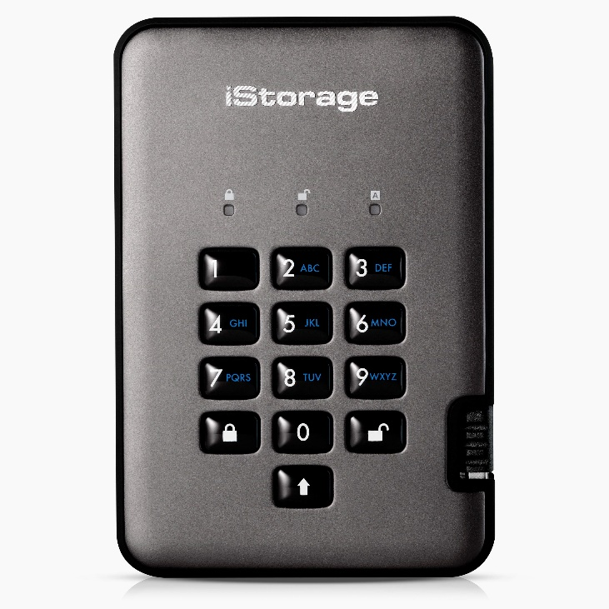
1. Plug in USB into laptop
2. Enter PIN number to unlock SSD
3. Boot into SSD command prompt when lights turn green
Figure 1 – iStorage SSD used at work
After booting into the SSD command prompt, I enter commands to select and apply the correct image. The cloning process takes around 15-20 minutes to apply the image before I can proceed on with the configuring step. Unfortunately, due to the strict security and sensitivity of the workplace, I am unable to disclose in-depth details about the process in this report.
During the configuring phase, it also takes about 15-20 minutes, encompassing tasks like driver installation, BIOS system updates for upgrading firmware, and allocating the laptops to their designated camps through a script installed from the SSD. The steps are time-consuming due the duration of the installation and updates.
After configuring, the laptop is passed to the JD team to join the laptop to the MINDEF domain through a LAN cable. The command “gpupdate /force” is used in the command prompt to update the group policies. JD usually ranges from 10-15 minutes, depending on how long it takes to update the group policy.
Overall, the entire re-imaging process from cloning to JD takes about 40-45 minutes to complete. Despite its seemingly straightforward steps, there are various potential points of error. Mistakes such as entering inputting wrong commands, selecting the wrong image to apply, or misconfiguring the laptop resulting in a system lockout that would require the whole process to be repeated.

Furthermore, we have to take into consideration of the never-ending flow of laptops one after another to do. To maintain efficiency, we often handle multiple laptops simultaneously to speed up the process, increasing the likelihood of human errors occurring.
The diagram below shows an easier analysis of the process.

5. Diversity and Inclusivity
One of the colleagues I have acquainted with is a 22 year old ITE Graduate. Having worked multiple jobs these past few years, she wanted to earn revenue, expand her resume, and experience different working environments. For example, she was once a kindergarten teacher for a year before working at the camp as a team coordinator.
After having a few conversations with her about her career path, I gained many insights about why she made such life choices. Despite being well-aware that most companies will not be willing to hire her due to the lack in her skillset, she still persists in applying to different jobs in hopes of being hired. She does not regret her choice, confident that she will continue working without resuming education. She recently resigned from the camp as she wanted to hunt for other jobs that might interest her more. We still keep in contact after her departure and said that she got hired to be a cashier at a nightclub.
We agreed that it is important to do what we enjoy, or we will dread every day at work, and that it is crucial to align our occupation with our passions while also considering financial stability as a fundamental aspect to one’s career. For her case, she enjoys the atmosphere at a club and getting hired for this job was what she has always wanted. As her passion aligns well with her occupation, and deriving income from it contributes to financial stability.

Furthermore, because of her education and social standing, it is believed that she will be only be accepted by blue collared jobs. Personally, I would like to have a white collared job instead. However, I still think that it is good to hop around different jobs, gaining different working experiences and cultures.
For example, after graduating, if I think that continuing cybersecurity as a career path may not be the best for me, it would be wise to try out different departments in the IT industry such as software engineering or data analytics. I can also be adventurous and explore other courses outside of the IT industry that may be of interest to me.

Reflection

1. SIP Learning Outcomes

1.1 Learning Outcomes
Throughout my SIP journey, I gained valuable hands-on experience in troubleshooting and resolving technical issues, both software and hardware issues, as a tech refresh engineer. Additionally, the opportunity of working together with a team enhanced my communication and teamwork abilities. These experiences have not only improved my technical expertise but also equipped me with essential soft skills that I believe will be invaluable in my future career.

1.2 Challenges Encountered
One of the challenges I faced was not knowing how to troubleshoot certain errors. The first few weeks of internship was traumatising as I was being thrown with endless errors and issues constantly appearing. I was living in constant paranoia, afraid of figuring out how to resolve them as I feared that it would end up a security flaw and could result in a huge problem. I had to constantly raise my issues to my colleague for help for every error I encountered, as it was crucial to always clarify and never assume. After weeks of practicing, I managed to get it into muscle memory and got the hang of it. I knew how to troubleshoot my errors myself and learn how to trace back certain errors and know how to resolve it.

1.3 Learning Gaps
Aside from the challenges I faced, I have also encountered a few learning gaps in my knowledge of the re-imaging process as well as work management. To close these gaps, I plan to clarify my doubts with my colleague or intern mates, and do more research for each step’s purpose. For work management, I have to learn to manage my time wisely and plan out my tasks in an organised manner when it comes to handling work.

2. Work Done

2.1 Major Incident
On a daily basis, we work on the entire re-imaging process from clone to JD, and always trying to achieve the daily quota. One time we had a sudden request of close to 400 laptops to complete in 2 weeks with a lack in manpower. While everyone panicked, I decided to use this opportunity to learn to take charge of this new never-ending stream of laptops. I had to follow the list of camps to assign for the team to work on.
There were endless issues arising such as extra laptops done, missing laptops from cabinets, and issues with laptops that need replacements. As I am the one keeping track of everything, I had to tend to these issues myself. It takes tremendous effort to take up such responsibility, and I messed up countless times such as losing count of laptops, and my mistakes costed my team doing less or extra laptops.
However, I am grateful for my colleague who willingly stepped in to calm me down, resolve my issues, organise my mess and help me get back on track. I managed to get a hold of myself and slowly got better at taking charge thanks to my colleague, and everything from then on went smoothly.

2.2 Areas of Strength
One of my strengths at work would be working at the configuring team as I navigate through the command prompt very seamlessly for installation of drivers and checking of folders. For example, there was a very hectic period once and I needed to be much more efficient in my work, till I was configuring on 12 laptops at once.
An area of improvement would be to cultivate a good habit of keeping things organised. Though it was very efficient working on 12 laptops at once, my table was still in a horrible mess. Having a neater workstation gives me a better view of my work and prevents myself from getting confused.

2.3 Takeaway
One crucial takeaway for me would be to always set realistic goals, plan out the tasks and achieve it within a reasonable period of time. This may not only apply in the workforce, but also in school, where there are tight deadlines for projects and assignments. Being more organised in my daily life refrains myself from getting anxious and worried all the time, and helps me to have a better view of my goal and accomplish my tasks accordingly.

3. Networking Insights

3.1 Networking Opportunities
As most of my colleagues were Temasek and Republic Polytechnic graduates who interned at the same place, I did not have many networking opportunities. However, I was able to socialise well with them as we were all of similar ages and relate well to each other on a similar level. Since they are fresh graduates, they were waiting for their National Service (NS) enlistment, and decided to extend their contract as a full-timer to kill time while waiting to be enlisted.

3.2 What I Learnt
I did not learn as much as I expected from them because they are just fresh graduates waiting for their enlistment, and they are just as confused on what they want for their future career. However, they all collectively agreed that it would be wise for me to either continue a cybersecurity career, or find another course in the IT industry that might interest me more as they think it would be a waste of time to learn something brand new outside of IT.

3.3 Improvement
One improvement to my networking skills would be to inquire about the other person’s background, experiences, and interests to lay a common ground. I can also offer insights related to my field of study, as sharing my knowledge can position myself to be a valuable resource.

4. Industry Insights
The IT industry is experiencing significant changes as a result of current artificial intelligence (AI) advancements, particularly in automation and cybersecurity. Operations are becoming more efficient thanks to AI-driven automation, which frees up human resources for important tasks. Real-time threat detection and continuous monitoring provided by AI in cybersecurity are improving defences. By enhancing efficiency, security, and generating new job prospects, these developments will completely transform the IT industry and raise the level of competition.
AI's automation of threat detection and incident response in the context of cybersecurity is enhancing efficiency. Response times are improved by AI's capacity and ability to scan massive databases for threat patterns, and experts have to adapt to working with AI systems. Overall, AI is enhancing the effectiveness of cybersecurity roles, strengthening defences against evolving threats.

My mentor underlined the value of ethics, openness, and justice in AI. We also talked about cutting-edge research in fields like computer vision and natural language processing, and AI's potential to reshape sectors like healthcare and finance. These insights highlighted exactly how extensive an impact AI can have across different industries.

5. Diploma Specific Requirements
As a cybersecurity student, the skills and scopes required as a tech refresh engineer did not directly align with my specialised skillset, but I discovered that certain security concepts proved invaluable. Understanding the criticality of resetting the laptop’s security settings and erasing existing personal data prior data to the cloning process provided a practical application of my knowledge. Additionally, my countless experiences with different operating systems’ terminal at school equipped me with the proficiency to effectively navigate through the command prompt at work. While I did not have the opportunity to fully leverage my cybersecurity expertise, these experiences reinforced the importance of security measures even in seemingly unrelated roles.
Furthermore, the skills learnt from a non-core module, Persuasive Communication (PCOMM), have been effective in facing my demanding superior who often set exceedingly high expectations. I had to convey the impracticality of achieving certain results within a short time. Using the skills learnt in PCOMM, I was able to sway my superior’s perspective, prompting a reconsideration of the feasibility of the given task due to the lack of manpower and other reasons.

Conclusion and Recommendations

1. Overall Reflection
In all honesty, I must admit this SIP has not been the most fulfilling experience. The skills required for my work were not relevant to my field of study and I did not have many opportunities to fully utilise and showcase the skills learnt in my diploma. However, certain minor security-related concepts required for the job scope were applicable and aided well in my understanding.
Furthermore, one of the most significant expertise I have obtained from this internship improving on my communication skills. Working in this environment required me to communicate well with my superiors, to be stand firm in my point and be confident in my persuasion. Additionally, being able to socialise easily with my colleagues helped to get me out of my comfort zone, also enhancing my communication skills.

2. Recommendations
One recommendation I would like to suggest would be to have the internship be more relevant to the diploma.
As a cybersecurity student, I was very discouraged knowing that the internship barely scratched the surface of what I learn in my diploma. The skills required to work were very insignificant to the concepts taught in my course, and the tasks assigned were relatively simple and only at times challenging. Overall, the nature of the work I was given did not align with the core objectives of my diploma.

My recommendation would be to have tasks that incorporate more of the idea of cybersecurity to the internship. As a cybersecurity student, involving certain fundamental concepts such as penetration testing, malware analysis or intrusion prevention into the internship will definitely make it much more enriching for the interns. By putting theory and concepts into hands-on experience at work can be a very fulfilling experience in one’s internship journey.

